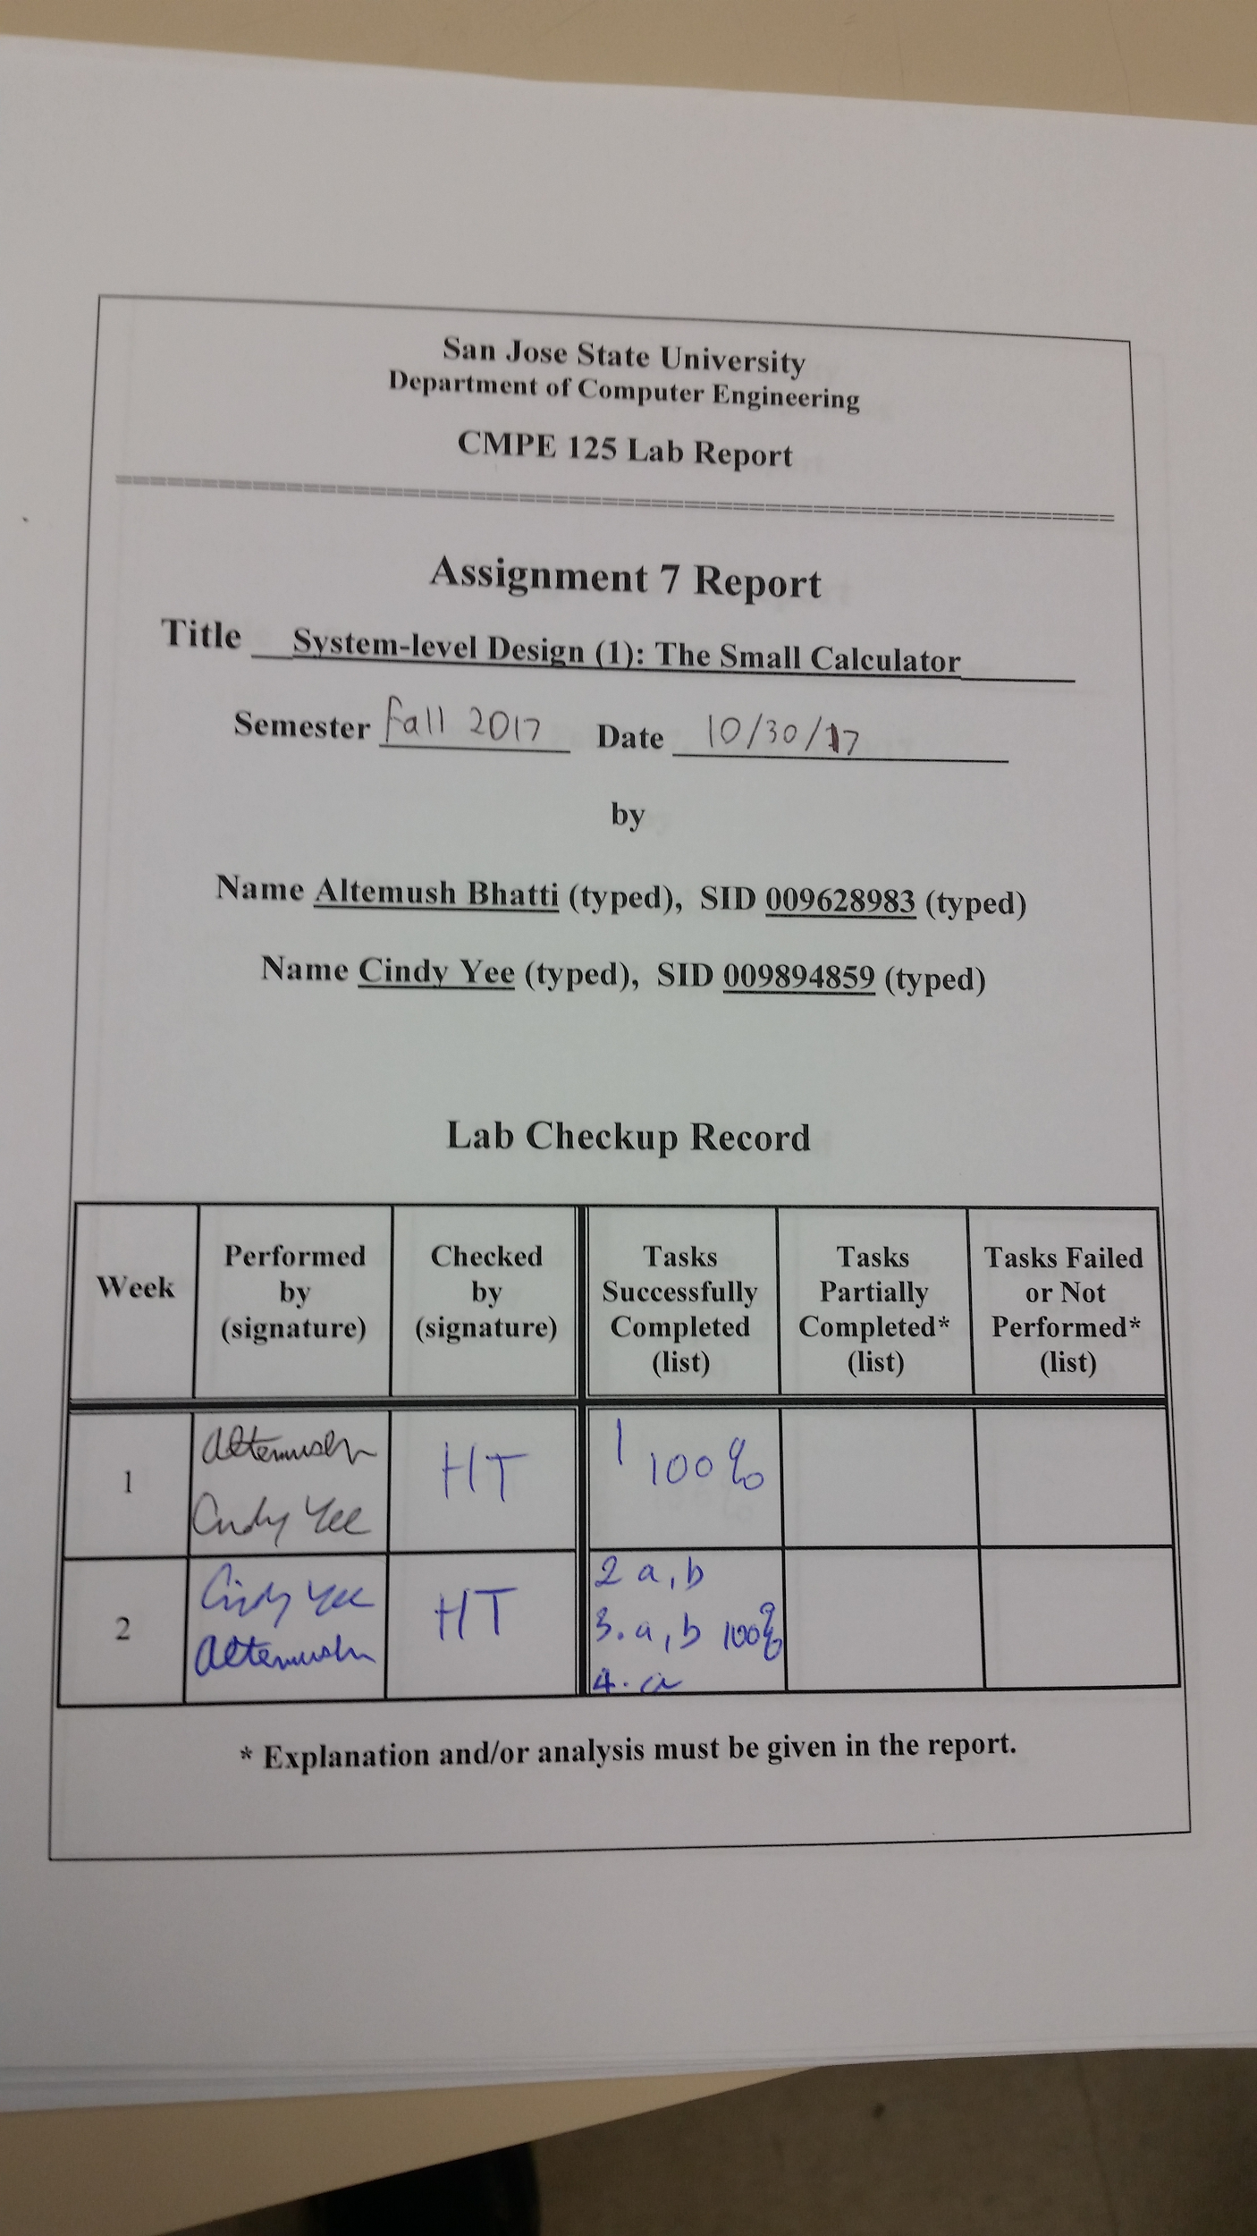

**Introduction**

The purpose of this lab was to be familiar with system-level design methodologies, with an emphasis on the control portion, and the and the design/verification/validation flow and Engineering Design Automation tools used in the lab. In this lab, we designed the control and the datapath of a small calculator that was able to perform to perform ADD, SUBTRACT, AND, and XOR operations. Self-checking testbenches were designed for both the control unit and the datapath. The whole system (control unit and datapath) was implemented on the Nexys4 DDR FPGA board.

**Design Methodology**

The control unit and datapath that were designed in this lab can be seen in the image below.

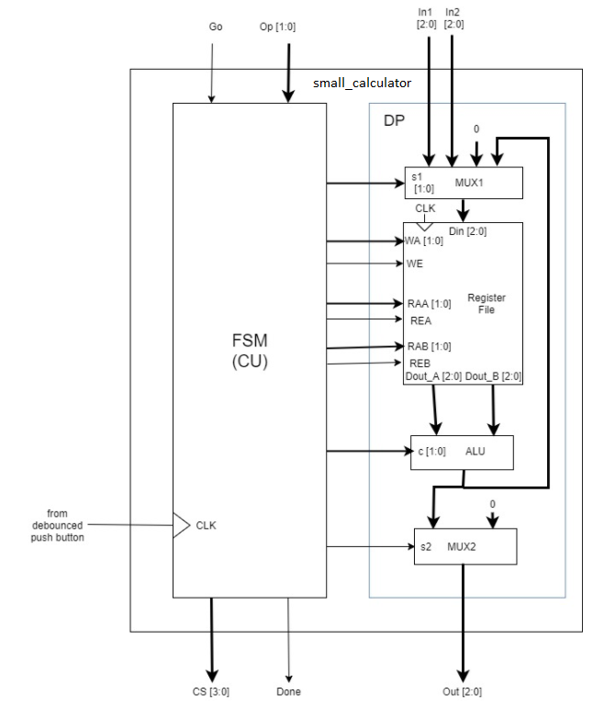

*Figure 1*: Schematic of the small calculator containing the control unit and the datapath.

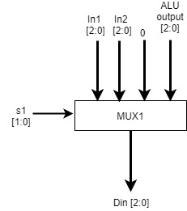

*Figure 2:* Block diagram of first mux

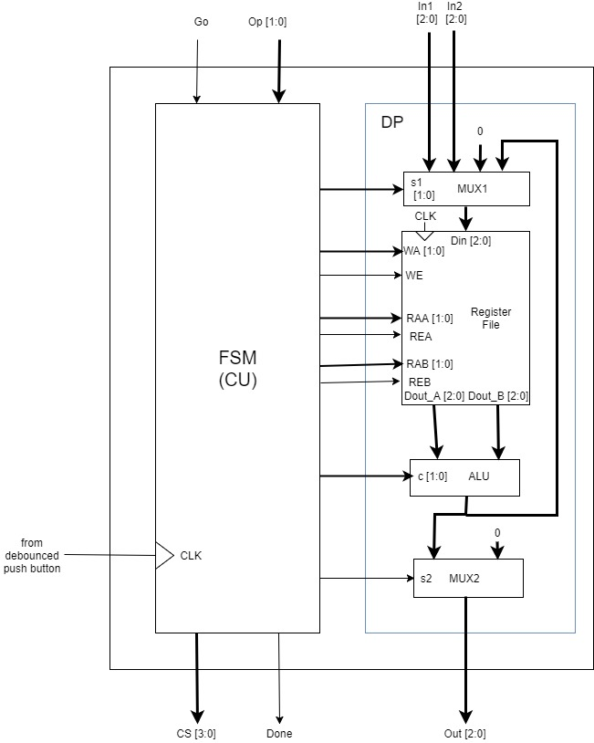

*Figure 3:* Block diagram of register file

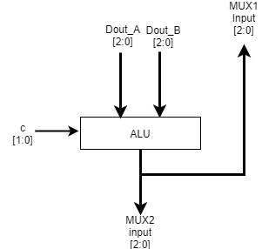

*Figure 4*: Block diagram of ALU

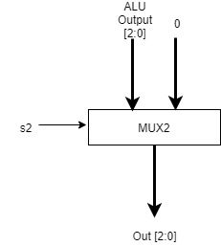

*Figure 5*: Block diagram of MUX2

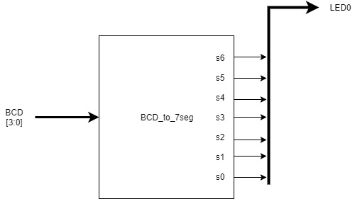

*Figure 6*: BCD to 7-segment module block diagram

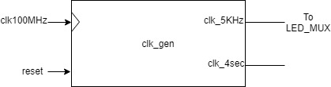

*Figure 7*: clock generator module block diagram

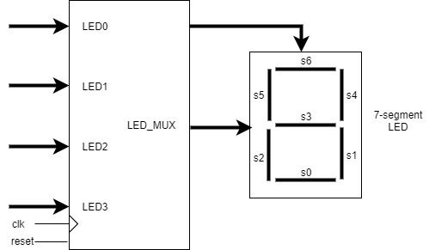

*Figure 8*: LED_MUX module block diagram with one 7-segment LED

The datapath contains a mux for selecting the desired input, a register file for storing the input and reading out the outputs, and ALU for performing either an ADD, SUBTRACT, AND, XOR operation (depending on the value of the ALU’s control), and another mux for selecting either 0 or the output of the ALU as the output of the datapath. The control unit is a finite state machine.

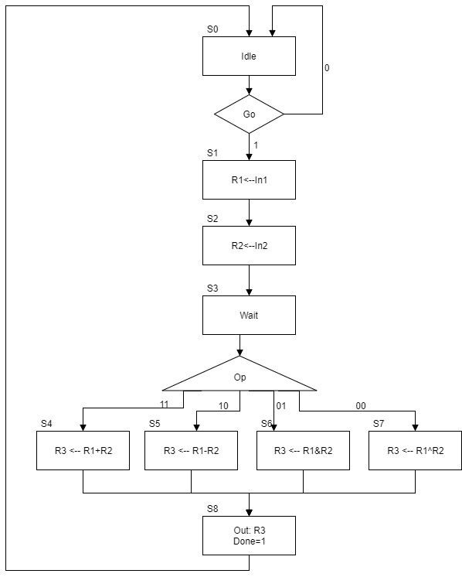

*Figure 9*: ASM Diagram of the the small calculator control unit

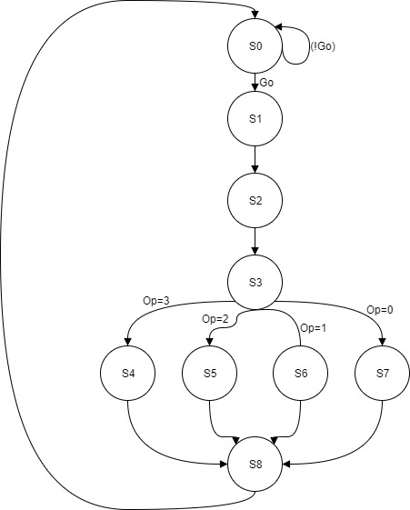

*Figure 10*: State Transition Diagram of Next States

For this system, first 2 3-bit inputs were loaded into the register file. Input 1 was loaded into R1 and the input 2 was loaded into R2. Then, one of the four operations were carried out on the two stored inputs. If Op was equal to 3, the two inputs were added together. If Op was equal to 2, input 2 was subtracted from input 1. If Op was equal to 1, the AND operation was performed on the two inputs. If Op was equal to 0, the XOr operation was performed on the two inputs. For each case, the result was stored into R3. Then, the result was outputted from the datapath, and the done flag was set to 1. This is a Moore state machine since the output depends only on the current state.

Table 1: ASM chart with outputs of the small calculator

|  |  |  |  |  |  |  |  |  |  |  |
| --- | --- | --- | --- | --- | --- | --- | --- | --- | --- | --- |
| **Input** | **Outputs** | | | | | | | | | |
| **CS** | **s1** | **wa** | **we** | **raa** | **rea** | **rab** | **reb** | **c** | **s2** | **Done** |
| S0 | 1 | 0 | 0 | 0 | 0 | 0 | 0 | 0 | 0 | 0 |
| S1 | 11 | 1 | 1 | 0 | 0 | 0 | 0 | 0 | 0 | 0 |
| S2 | 10 | 10 | 1 | 0 | 0 | 0 | 0 | 0 | 0 | 0 |
| S3 | 1 | 0 | 0 | 0 | 0 | 0 | 0 | 0 | 0 | 0 |
| S4 | 0 | 11 | 1 | 1 | 1 | 10 | 1 | 0 | 0 | 0 |
| S5 | 0 | 11 | 1 | 1 | 1 | 10 | 1 | 1 | 0 | 0 |
| S6 | 0 | 11 | 1 | 1 | 1 | 10 | 1 | 10 | 0 | 0 |
| S7 | 0 | 11 | 1 | 1 | 1 | 10 | 1 | 11 | 0 | 0 |
| S8 | 1 | 0 | 0 | 11 | 1 | 11 | 1 | 10 | 1 | 1 |

Table 2: List of modules used

|  |  |
| --- | --- |
| File Name | Description |
| *DP.v* | datapath design code |
| *MUX1.v* | 4 to 1 mux for datapath inputs |
| *RF.v* | register file for the datapath registers R1,R2, and R3 |
| *ALU.v* | ALU for the datapath operations |
| *MUX2.v* | 2 to 1 mux for the datapath output |
| *DP_tb.v* | self-checking testbench for the datapath |
| *CU.v* | Finite State Machine or Control Unit of the small calculator |
| *CU_tb.v* | self-checking testbench for the control unit of the small calculator |
| *small_calculator.v* | design module for the small calculator --connecting DP with CU |
| *small_calculator_fpga.v* | top-level module for the small calculator FPGA implementation |
| *clk_gen.v* | utility module to generate the clock for the FPGA |
| *button_debouncer.v* | utility module for the debouncer on the FPGA |
| *bcd_to_7seg.v* | utility module to determine the 7-segment display output |
| *led_mux.v* | utility module for signals to be displayed on the 7-segment display |
| *small_calculator_fpga.xdc* | constraint file for the small calculator FPGA validation |

**Simulation Results**

The simulation of all three testbenches were a success. They were verified through self-checking messages and through eye-ball testing.

The simulation for the DP ran through all possible inputs, as expected from a self-checking testbench.

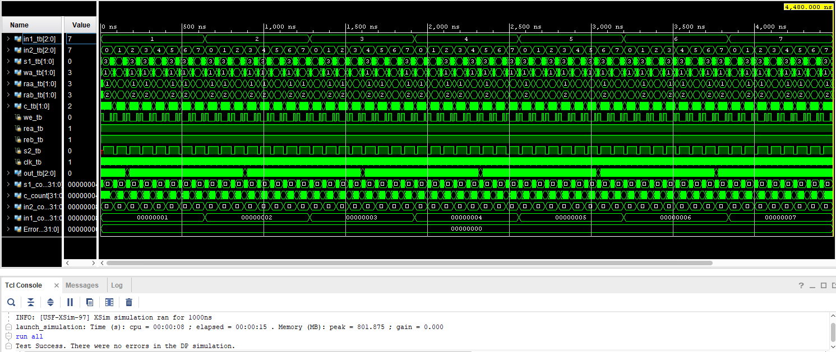

Figure 11: DP testbench simulation’s full waveform with a test success message

For the DP testbench, In1 was written to R1 in the first clock cycle, then In2 was written to R2 in the next clock cycle. After that, the ALU control will alternate and the output MUX2 will be enabled to allow outputs to show and not be zero. We then check that the last ALU op was successfully entered into R3. From eyeball testing, we can see that the DP testbench is fully functioning as expected.

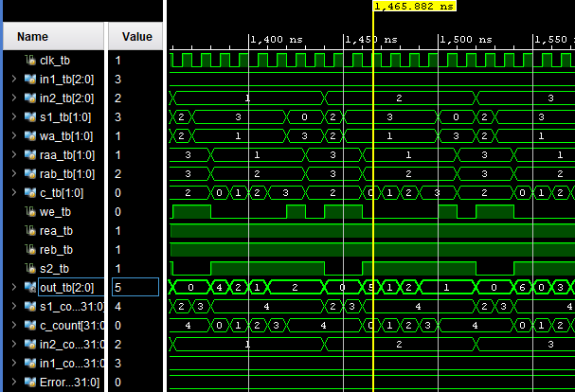

Figure 12: Zoomed in view of the DP testbench simulation

The simulation for the Control Unit was a success, as verified by eyeball testing of the waveforms and by displaying error messages in the console. The states all switched from S0 to S1 when Go was active, S1 to S2, and so on corresponding to the ASM chart above. Each state was one clock cycle as shown in the two figures below. The other inputs going into the datapath were checked using the self-checking messages.

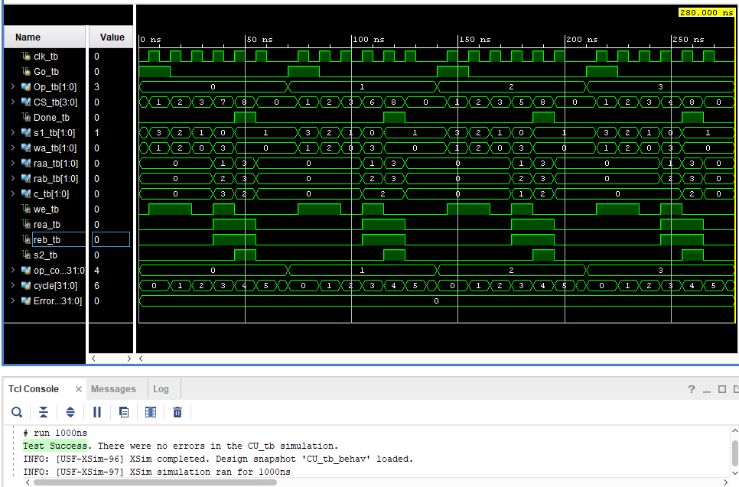

Figure 13: CU simulation results with self-checking messages displayed

From the self-checking messages and eyeball testing of the zoomed in view of the small calculator’s testbench simulation we can verify that there were no errors. The states correctly switched from S0 to S1 when Go was activated at the right moment, S1 to S2, S2 to S3, S3 to S4,S5,S6, or S7 depending on Op, and then to S8, corresponding to the ASM diagram and output charts. The outputs of the testbench were also correct based on the bit size constraints and the inputs to the testbench.

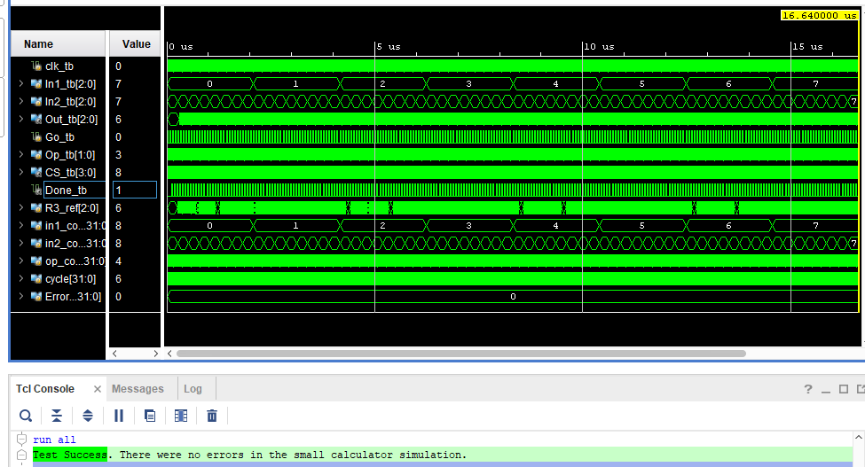

Figure 14: Small calculator simulation results with self-checking messages displayed

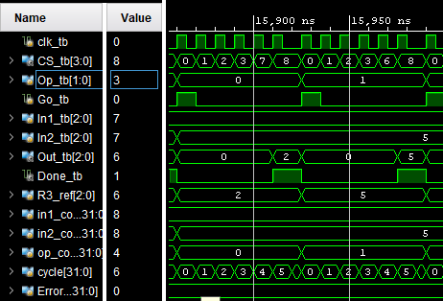

Figure 15: Small calculator simulation (Zoomed in view)

**FPGA Validation**

The FPGA validation for the small calculator where the control unit acts as a finite state machine controlling the datapath was a success. The outputs of the small calculator system CS, Out, and Done correctly corresponded to the inputs of the system. Figure X shows the FPGA board with all the small calculator system’s inputs as switches or buttons, the current state CS and the output Out in the 7-segment display and the Done flag as an LED.

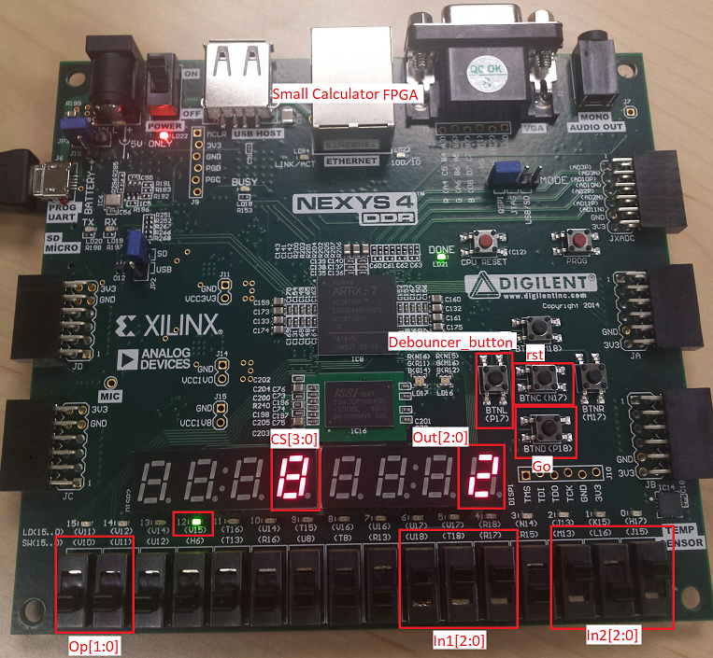

Figure 16: Small Calculator FPGA layout with the inputs and outputs labeled

From figure 17, we can observe the that with inputs Op=0, In1=7, and In2=5 at the current state CS=S8, Out=2. When Op=0, R3←R1^R2 at CS=S7. Out=2 is the correct result because the equation 111 XOR 101= 010.

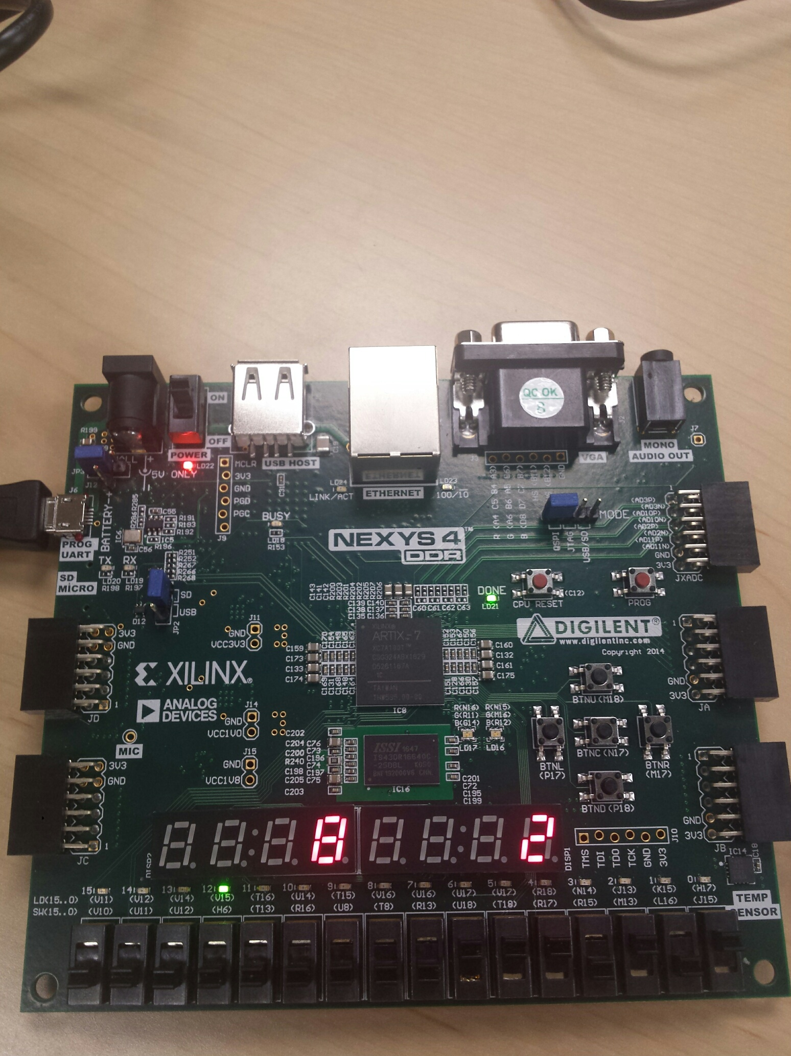Figure 17: FPGA at CS=S8, Op=0, In1=7, and In2=5

From figure 18, we can observe the that with inputs Op=1, In1=7, and In2=5 at the current state CS=S8, Out=5. When Op=0, R3←R1&R2 at CS=S7. Out=5 is the correct result because the equation 111 AND 101= 101.

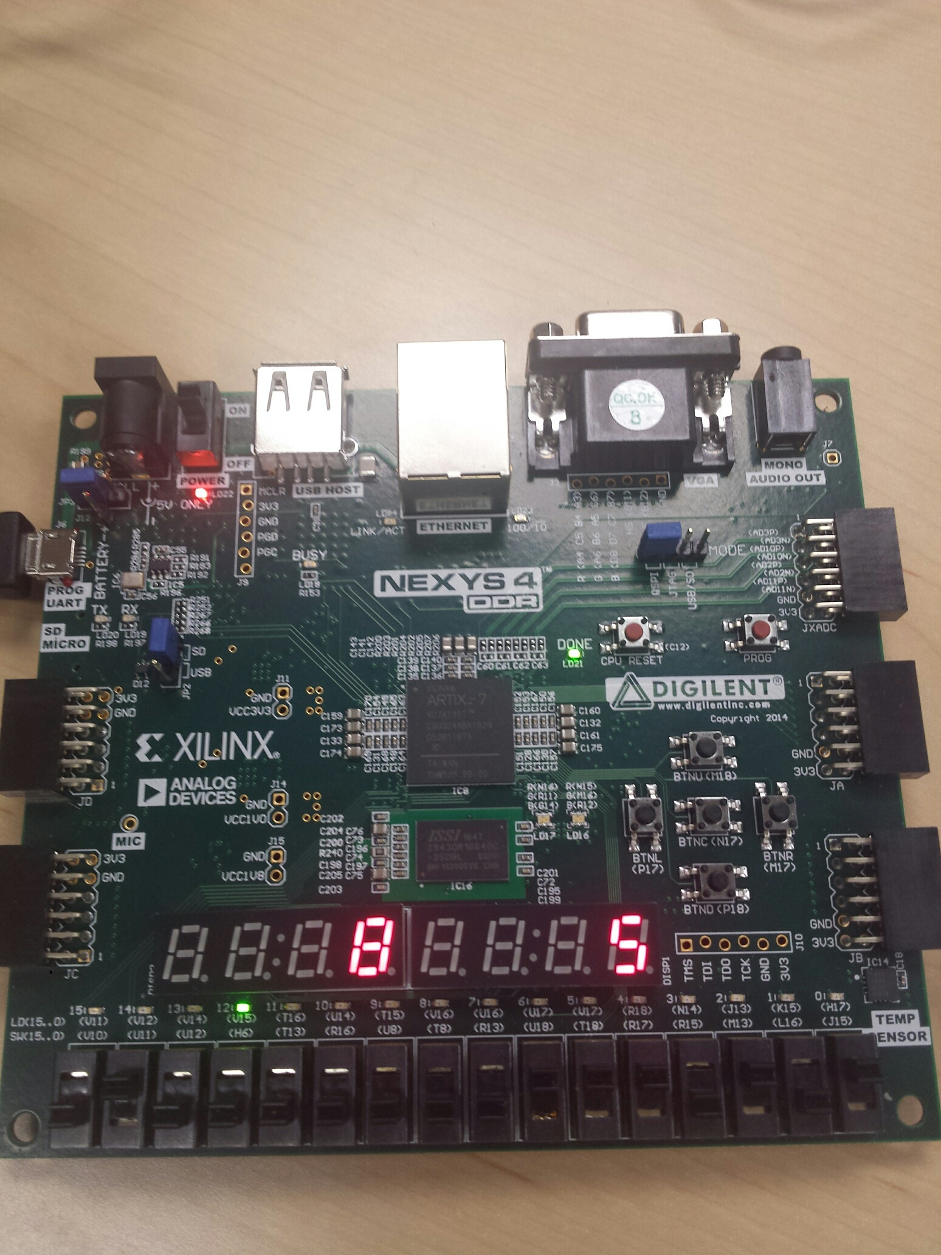Figure 18: FPGA at CS=S8, Op=1, In1=7, and In2=5

From figure 19, we can observe the that with inputs Op=2, In1=7, and In2=5 at the current state CS=S8, Out=2. When Op=0, R3←R1-R2 at CS=S7. Out=2 is the correct result because the equation 111 - 101= 010 or 7-5=2.

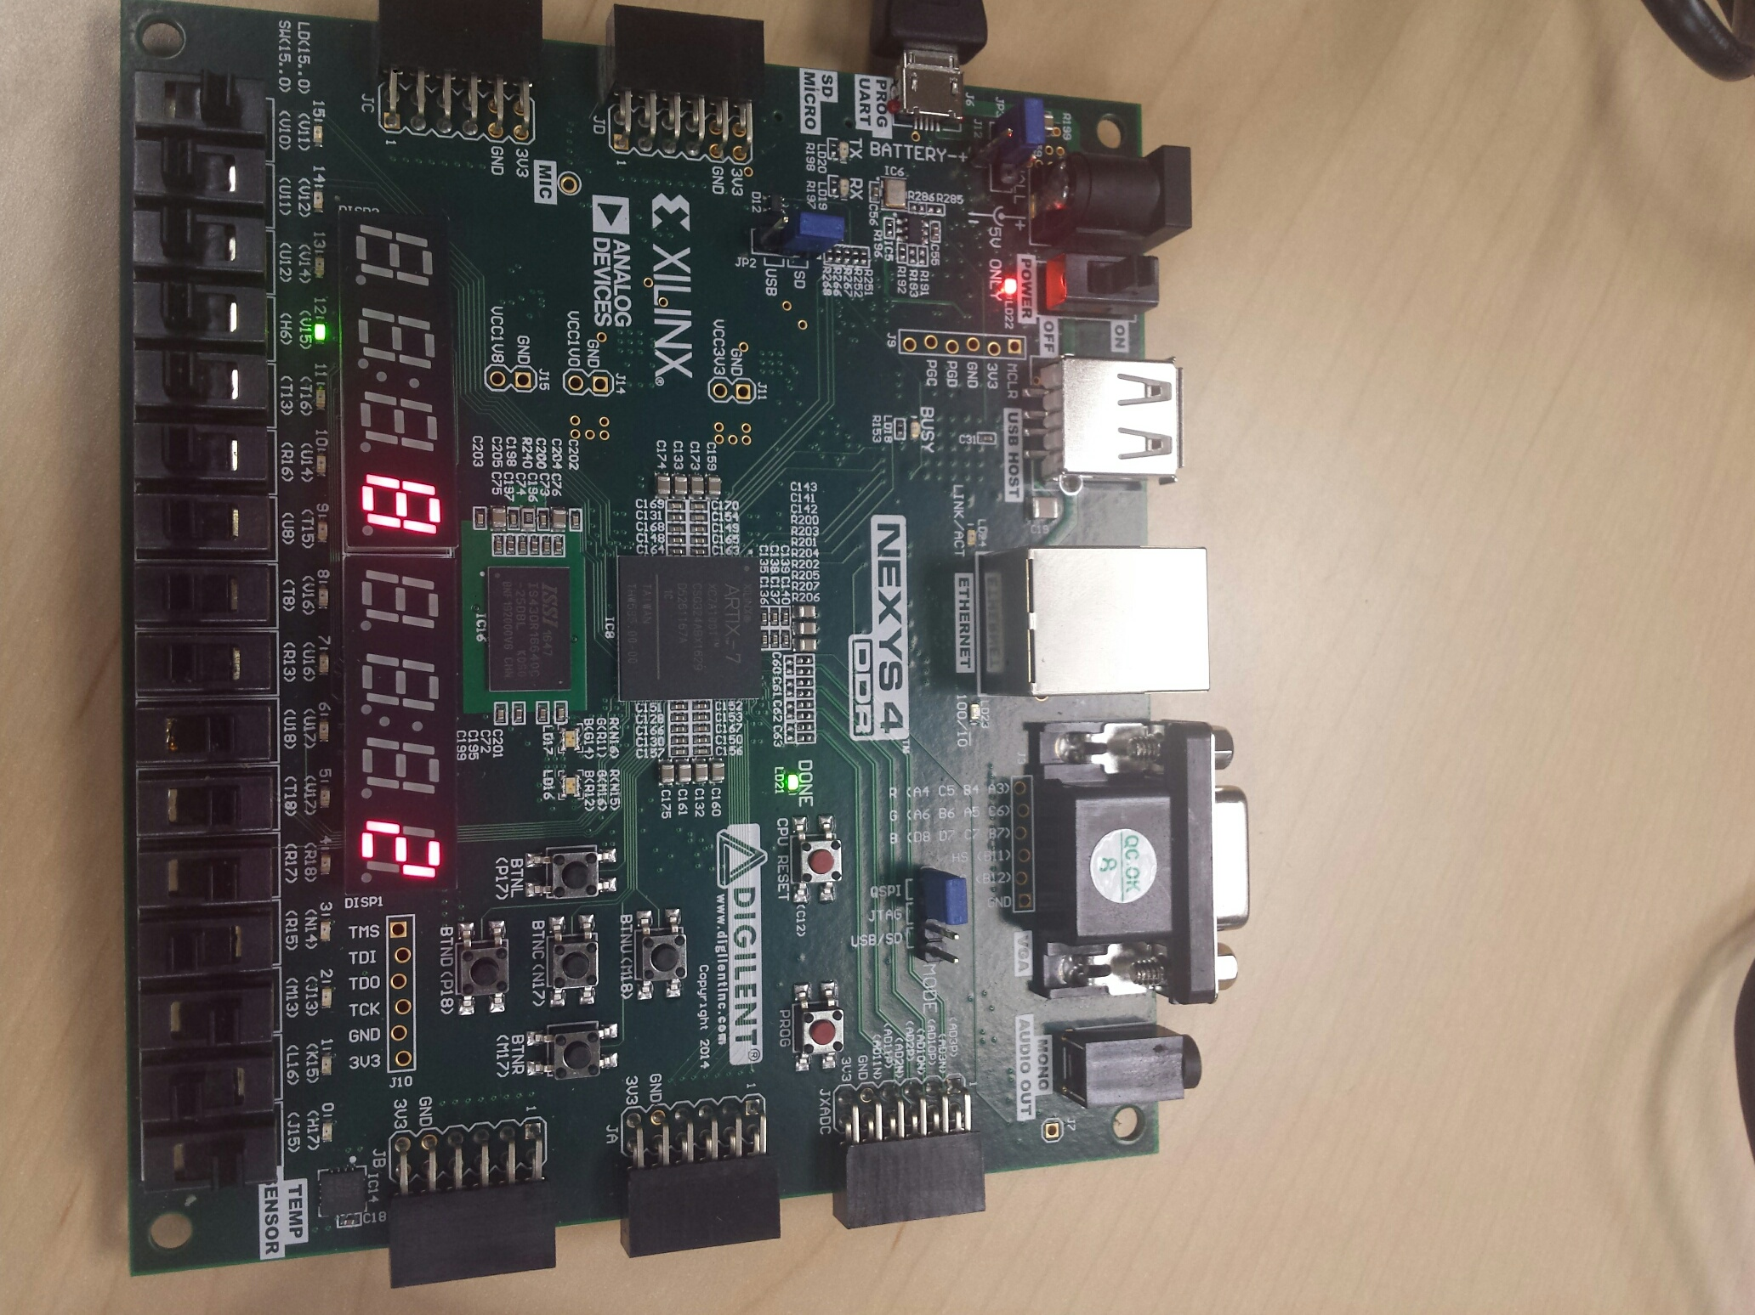Figure 19: FPGA at CS=S8, Op=2, In1=7, and In2=5

From figure 20, we can observe the that with inputs Op=3, In1=7, and In2=5 at the current state CS=S8, Out=2. When Op=0, R3←R1+R2 at CS=S7. Out=4 is the correct result because Out is limited by 3 bits and the first three bits of the equation 111 + 101= 010.

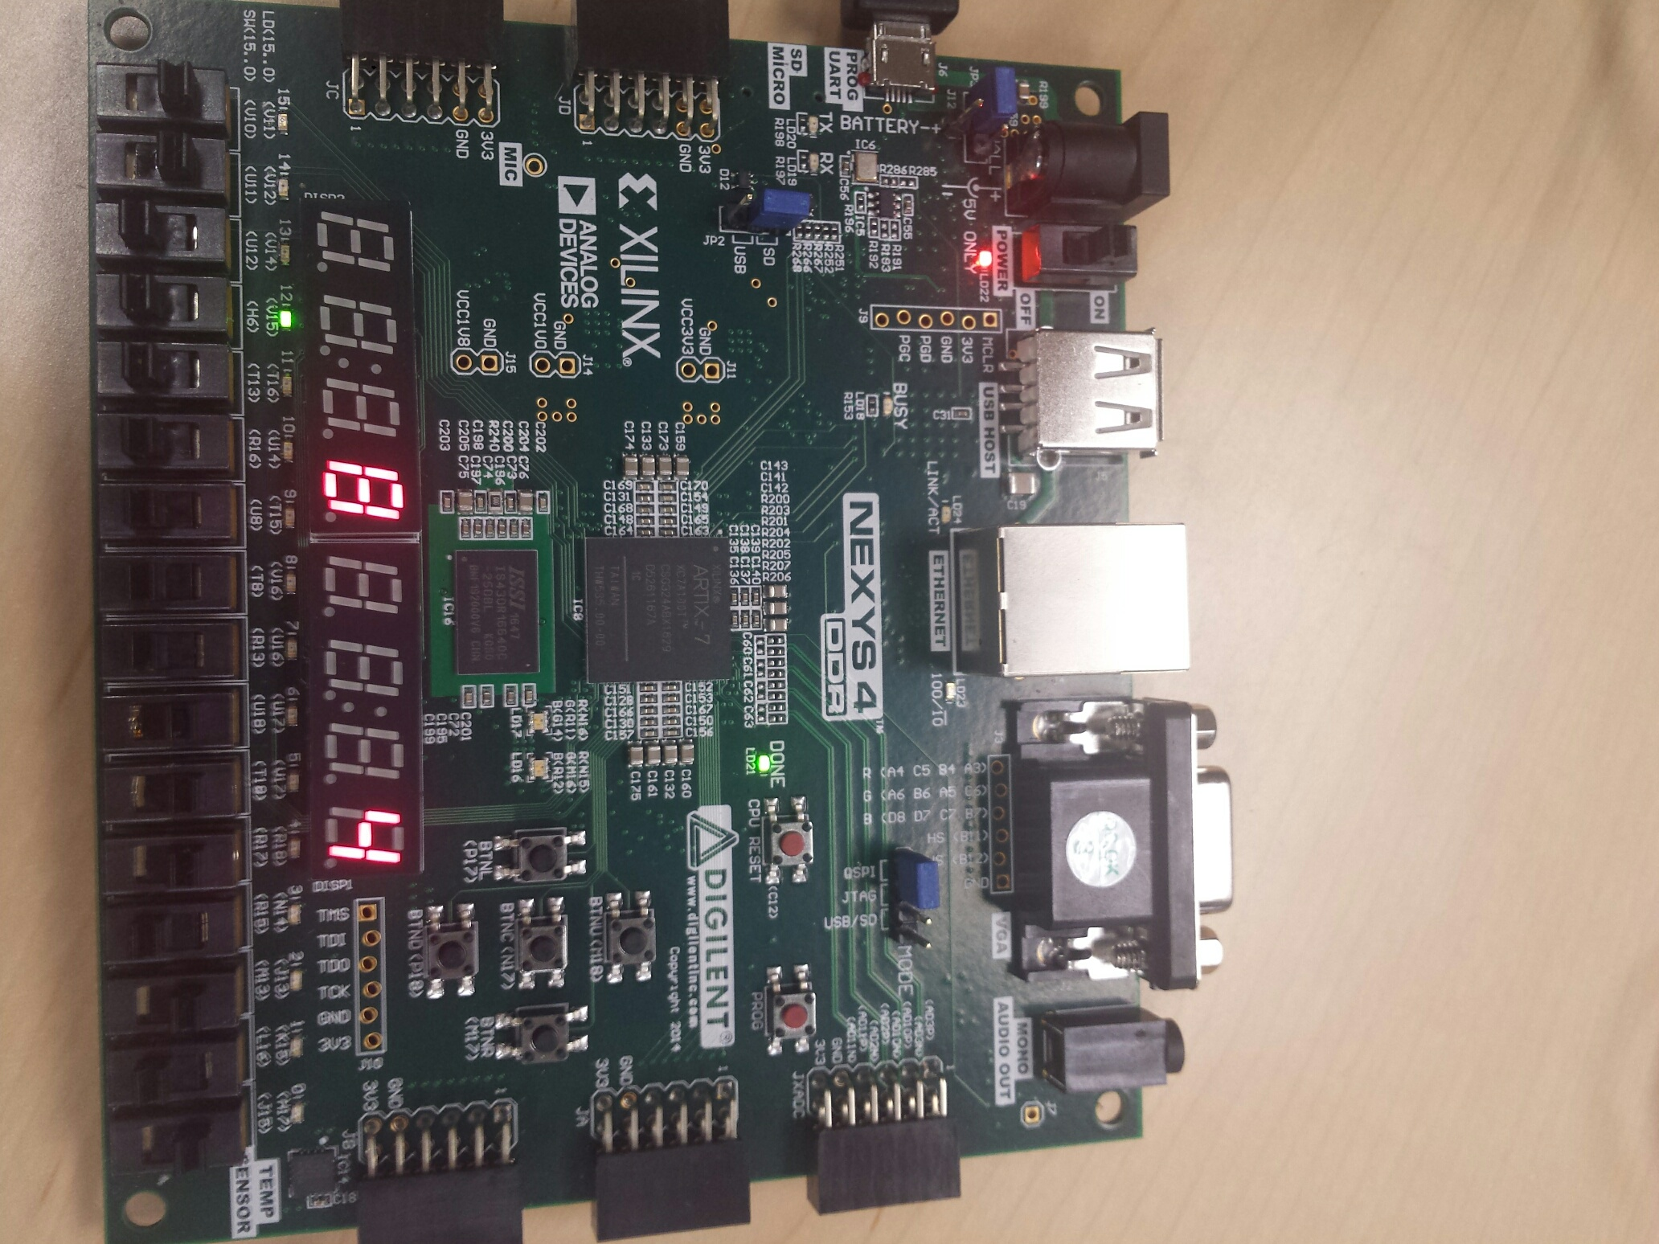Figure 20: FPGA at CS=S8, Op=3, In1=7, and In2=5

**Conclusion**

The design of the datapath, control unit, and the integrated system of the datapath and the control unit was a success. The testbenches for all three designs were verified through self-checking messages through the console and eyeball testing on the simulation waveforms. The FPGA validation of the small calculator was also a success, with the outputs reacting accordingly to the inputs of the system.

**Appendix**

1. **File DP.v- datapath design code**

module DP(in1, in2, s1, clk, wa, we, raa, rea, rab, reb, c, s2, out);

input[2:0] in1, in2; //data inputs

input[1:0] s1, wa, raa, rab, c;

input we, rea, reb, s2, clk;

output[2:0] out;

wire[2:0] mux1out;

wire[2:0] douta;

wire[2:0] doutb;

wire[2:0] aluout; // instantiate the building blocks

MUX1 U0(.in1(in1), .in2(in2), .in3(3'b000), .in4(aluout), .s1(s1), .m1out(mux1out));

RF U1(.clk(clk), .rea(rea), .reb(reb), .raa(raa), .rab(rab), .we(we), .wa(wa),

.din(mux1out), .douta(douta), .doutb(doutb));

ALU U2(.in1(douta), .in2(doutb), .c(c), .aluout(aluout));

MUX2 U3(.in1(aluout), .in2(3'b000), .s2(s2), .m2out(out));

endmodule//DP

1. **File MUX1.v - 4 to 1 mux for datapath inputs**

module MUX1(in1, in2, in3, in4, s1, m1out);

input[2:0] in1, in2, in3, in4;

input[1:0] s1;

output reg[2:0] m1out;

always @(in1, in2, in3, in4, s1)

begin

case(s1)

2'b11: m1out = in1;

2'b10: m1out = in2;

2'b01: m1out = in3;

default:m1out = in4; // 2'b00

endcase

end

endmodule//MUX1

1. **File RF.v - register file for the datapath registers R1,R2, and R3**

module RF(clk, rea, reb, raa, rab, we, wa, din, douta, doutb);

input clk, rea, reb, we;

input[1:0] raa, rab, wa;

input[2:0] din;

output reg[2:0] douta, doutb;

reg[2:0] RegFile [3:0];

always@(rea, reb, raa, rab)

begin

if (rea)

douta = RegFile[raa];

else

douta = 3'b000;

if (reb)

doutb = RegFile[rab];

else doutb = 3'b000;

end

always@(posedge clk)

begin

if (we)

RegFile[wa] <= din;

else

RegFile[wa] <= RegFile[wa];

end

endmodule//RF

1. **File ALU.v - ALU for the datapath operations**

module ALU (in1, in2, c, aluout);

input[2:0] in1, in2;

input[1:0] c;

output reg[2:0] aluout;

always@ (in1, in2, c)

begin

case(c)

2'b00: aluout = in1 + in2;

2'b01: aluout = in1 - in2;

2'b10: aluout = in1 & in2;

default:aluout = in1 ^ in2; // 2'b11;

endcase

end

endmodule//ALU

1. **File MUX2.v - 2 to 1 mux for the datapath output**

module MUX2 (in1, in2, s2, m2out);

input[2:0] in1, in2;

input s2;

output reg[2:0] m2out;

always@ (in1, in2, s2)

begin

if (s2)

m2out = in1;

else

m2out = in2;

end

endmodule//MUX2

1. **File DP_tb.v - self-checking testbench for the datapath**

`timescale 1ns / 1ps

module DP_tb();

reg[2:0] in1_tb, in2_tb; //data inputs

reg[1:0] s1_tb, wa_tb, raa_tb, rab_tb, c_tb;

reg we_tb, rea_tb, reb_tb, s2_tb, clk_tb;

wire[2:0] out_tb;

integer s1_count,c_count,s2_count,in2_count,in1_count;

integer ErrorCount;

DP DataPath(in1_tb, in2_tb, s1_tb, clk_tb, wa_tb, we_tb, raa_tb, rea_tb, rab_tb, reb_tb, c_tb, s2_tb, out_tb );

initial

begin

clk_tb=0;

ErrorCount=0;

rea_tb=1;

reb_tb=1;

we_tb=1;

s1_tb=1;

wa_tb=0;

raa_tb=0;

rab_tb=0;

for(in1_count=1;in1_count<8;in1_count=in1_count+1)

begin

assign in1_tb=in1_count;

for(in2_count=0;in2_count<8;in2_count=in2_count+1)

begin

assign in2_tb=in2_count;

we_tb=1;

//write mux inputs in1 and in2 to RF

for(s1_count=2;s1_count<4;s1_count=s1_count+1)

begin

s1_tb=s1_count;

if(s1_count==2)

wa_tb=2; //In2 to R2

else if(s1_count==3)

wa_tb=1; //In1 to R1

#10;

end//end s1_count

we_tb=0;

//Go through all possible ALU operations

raa_tb=1; //R1

rab_tb=2; //R2

//0=R1+R2, 1=R1-R2, 2=R1&R2, 3=R1^R2

for(c_count=0;c_count<4;c_count=c_count+1)

begin

c_tb=c_count; //#5;

s2_tb=1; #10;

if(s2_tb==0 && out_tb!=0)

$display("Error at MUX2 0");

else if(s2_tb==1)

begin

if(c_tb==0 && out_tb!=(in1_tb+in2_tb))

begin

ErrorCount=ErrorCount+1;

$display("Error at ALUadd in1=%d, in2=%d, out=%d, time=%d",in1_tb,in2_tb,out_tb,$time);

end

else if(c_tb==1 && out_tb!=(in1_tb-in2_tb))

begin

ErrorCount=ErrorCount+1;

$display("Error at ALUsub in1=%d, in2=%d, out=%d, time=%d",in1_tb,in2_tb,out_tb,$time);

end

else if(c_tb==2 && out_tb!=(in1_tb&in2_tb))

begin

ErrorCount=ErrorCount+1;

$display("Error at ALU& in1=%d, in2=%d, out=%d, time=%d",in1_tb,in2_tb,out_tb,$time);

end

else if(c_tb==3 && out_tb!=(in1_tb^in2_tb))

begin

ErrorCount=ErrorCount+1;

$display("Error at ALU^ in1=%d, in2=%d, out=%d, time=%d",in1_tb,in2_tb,out_tb,$time);

end

end//end if

end//end c_count

we_tb=1;

s1_tb=0; //write output to R3

wa_tb=3;#10;

we_tb=0;

//See what value R3 has (check if ALU did operation correctly)

raa_tb=3;

rab_tb=3;

c_tb=2; //R3&R3=R3

s2_tb=1;#10;

s2_tb=0;

end//end in2_count

end//end in1_count

if(ErrorCount==0)

$display("Test Success. There were no errors in the DP simulation.");

$stop;

end//endinitial

always #5 clk_tb<=~clk_tb;

endmodule

1. **File CU.v - Finite State Machine or Control Unit of the small calculator**

`timescale 1ns / 1ps

module CU( input CLK, Go,input [1:0] Op, output reg [3:0] CS, output reg Done,

output reg [1:0] s1, wa, raa, rab, c,

output reg we, rea, reb, s2);

reg [3:0] NS;

parameter S0=4'b0000,

S1=4'b0001,

S2=4'b0010,

S3=4'b0011,

S4=4'b0100,

S5=4'b0101,

S6=4'b0110,

S7=4'b0111,

S8=4'b1000;

initial begin

CS=S0;

end

always@(CS,Op,Go)

begin

case(CS)

S0: begin

if(Go)NS<=S1;

else NS<=S0;

end

S1: NS<=2;

S2: NS<=3;

S3: begin

if(Op==3) NS<=S4;

else if(Op==2) NS<=S5;

else if(Op==1) NS<=S6;

else if(Op==0) NS<=S7;

end

S4: NS<=S8;

S5: NS<=S8;

S6: NS<=S8;

S7: NS<=S8;

S8: NS<=S0;

default: NS<=S0;

endcase

end

always@(posedge CLK)

begin

CS<=NS;

end

always@(CS)

begin

case(CS)

S0: begin

s1=1; wa=0; we=0; raa=0; rea=0; rab=0; reb=0; c=0; s2=0; Done=0;

end

S1: begin

s1=3; wa=1; we=1; raa=0; rea=0; rab=0; reb=0; c=0; s2=0; Done=0;

end

S2: begin

s1=2; wa=2; we=1; raa=0; rea=0; rab=0; reb=0; c=0; s2=0; Done=0;

end

S3: begin

s1=1; wa=0; we=0; raa=0; rea=0; rab=0; reb=0; c=0; s2=0; Done=0;

end

S4: begin

s1=0; wa=3; we=1; raa=1; rea=1; rab=2; reb=1; c=0; s2=0; Done=0;

end

S5: begin

s1=0; wa=3; we=1; raa=1; rea=1; rab=2; reb=1; c=1; s2=0; Done=0;

end

S6: begin

s1=0; wa=3; we=1; raa=1; rea=1; rab=2; reb=1; c=2; s2=0; Done=0;

end

S7: begin

s1=0; wa=3; we=1; raa=1; rea=1; rab=2; reb=1; c=3; s2=0; Done=0;

end

S8: begin

s1=1; wa=0; we=0; raa=3; rea=1; rab=3; reb=1; c=2; s2=1; Done=1;

end

default: begin

s1=1; wa=0; we=0; raa=0; rea=0; rab=0; reb=0; c=0; s2=0; Done=0;

end

endcase

end

endmodule

1. **File CU_tb.v - self-checking testbench for the control unit of the small calculator**

`timescale 1ns / 1ps

module CU_tb();

reg clk_tb;

reg Go_tb;

reg [1:0] Op_tb;

wire [3:0] CS_tb;

wire Done_tb;

wire [1:0] s1_tb, wa_tb, raa_tb, rab_tb, c_tb;

wire we_tb, rea_tb, reb_tb, s2_tb;

integer op_count, cycle, ErrorCount;

CU control_unit( clk_tb, Go_tb, Op_tb, CS_tb, Done_tb,

s1_tb, wa_tb, raa_tb, rab_tb, c_tb,

we_tb, rea_tb, reb_tb, s2_tb );

initial

begin

clk_tb=0;

ErrorCount=0;

Go_tb=1;

for(op_count=0;op_count<4;op_count=op_count+1)

begin

Op_tb=op_count;

Go_tb=1;

for(cycle=0;cycle<6;cycle=cycle+1)

begin

if(cycle==0)begin Go_tb=1;#5; end

else Go_tb=0;

clk_tb=1;#5;

case(CS_tb)

0: begin

if({s1_tb, wa_tb, we_tb,raa_tb, rea_tb, rab_tb, reb_tb, c_tb, s2_tb, Done_tb}!= {15'b01_00_0_00_0_00_0_00_0_0})

begin

$display("CU_tb has an error attime=%d CS=%d, s1_tb=%b, wa_tb=%b, we_tb=%b,raa_tb=%b, rea_tb=%b, rab_tb=%b, reb_tb=%b, c_tb=%b, s2_tb=%b, Done_tb=%b",

$time, CS_tb, s1_tb, wa_tb, we_tb,raa_tb, rea_tb, rab_tb, reb_tb, c_tb, s2_tb, Done_tb);

ErrorCount=ErrorCount+1;

end

end

1: begin

if({s1_tb, wa_tb, we_tb,raa_tb, rea_tb, rab_tb, reb_tb, c_tb, s2_tb, Done_tb}!= {15'b11_01_1_00_0_00_0_00_0_0})

begin

$display("CU_tb has an error attime=%d CS=%d, s1_tb=%b, wa_tb=%b, we_tb=%b,raa_tb=%b, rea_tb=%b, rab_tb=%b, reb_tb=%b, c_tb=%b, s2_tb=%b, Done_tb=%b",

$time, CS_tb, s1_tb, wa_tb, we_tb,raa_tb, rea_tb, rab_tb, reb_tb, c_tb, s2_tb, Done_tb);

ErrorCount=ErrorCount+1;

end

end

2: begin

if({s1_tb, wa_tb, we_tb,raa_tb, rea_tb, rab_tb, reb_tb, c_tb, s2_tb, Done_tb}!= {15'b10_10_1_00_0_00_0_00_0_0})

begin

$display("CU_tb has an error attime=%d CS=%d, s1_tb=%b, wa_tb=%b, we_tb=%b,raa_tb=%b, rea_tb=%b, rab_tb=%b, reb_tb=%b, c_tb=%b, s2_tb=%b, Done_tb=%b",

$time, CS_tb, s1_tb, wa_tb, we_tb,raa_tb, rea_tb, rab_tb, reb_tb, c_tb, s2_tb, Done_tb);

ErrorCount=ErrorCount+1;

end

end

3: begin

if({s1_tb, wa_tb, we_tb,raa_tb, rea_tb, rab_tb, reb_tb, c_tb, s2_tb, Done_tb}!= {15'b01_00_0_00_0_00_0_00_0_0})

begin

$display("CU_tb has an error attime=%d CS=%d, s1_tb=%b, wa_tb=%b, we_tb=%b,raa_tb=%b, rea_tb=%b, rab_tb=%b, reb_tb=%b, c_tb=%b, s2_tb=%b, Done_tb=%b",

$time, CS_tb, s1_tb, wa_tb, we_tb,raa_tb, rea_tb, rab_tb, reb_tb, c_tb, s2_tb, Done_tb);

ErrorCount=ErrorCount+1;

end

end

4: begin

if(Op_tb!=3 || {s1_tb, wa_tb, we_tb,raa_tb, rea_tb, rab_tb, reb_tb, c_tb, s2_tb, Done_tb}!= {15'b00_11_1_01_1_10_1_00_0_0})

begin

$display("CU_tb has an error attime=%d CS=%d, s1_tb=%b, wa_tb=%b, we_tb=%b,raa_tb=%b, rea_tb=%b, rab_tb=%b, reb_tb=%b, c_tb=%b, s2_tb=%b, Done_tb=%b",

$time, CS_tb, s1_tb, wa_tb, we_tb,raa_tb, rea_tb, rab_tb, reb_tb, c_tb, s2_tb, Done_tb);

ErrorCount=ErrorCount+1;

end

end

5: begin

if(Op_tb!=2 || {s1_tb, wa_tb, we_tb,raa_tb, rea_tb, rab_tb, reb_tb, c_tb, s2_tb, Done_tb}!= {15'b00_11_1_01_1_10_1_01_0_0})

begin

$display("CU_tb has an error attime=%d CS=%d, s1_tb=%b, wa_tb=%b, we_tb=%b,raa_tb=%b, rea_tb=%b, rab_tb=%b, reb_tb=%b, c_tb=%b, s2_tb=%b, Done_tb=%b",

$time, CS_tb, s1_tb, wa_tb, we_tb,raa_tb, rea_tb, rab_tb, reb_tb, c_tb, s2_tb, Done_tb);

ErrorCount=ErrorCount+1;

end

end

6: begin

if(Op_tb!=1 || {s1_tb, wa_tb, we_tb,raa_tb, rea_tb, rab_tb, reb_tb, c_tb, s2_tb, Done_tb}!= {15'b00_11_1_01_1_10_1_10_0_0})

begin

$display("CU_tb has an error attime=%d CS=%d, s1_tb=%b, wa_tb=%b, we_tb=%b,raa_tb=%b, rea_tb=%b, rab_tb=%b, reb_tb=%b, c_tb=%b, s2_tb=%b, Done_tb=%b",

$time, CS_tb, s1_tb, wa_tb, we_tb,raa_tb, rea_tb, rab_tb, reb_tb, c_tb, s2_tb, Done_tb);

ErrorCount=ErrorCount+1;

end

end

7: begin

if(Op_tb!=0 || {s1_tb, wa_tb, we_tb,raa_tb, rea_tb, rab_tb, reb_tb, c_tb, s2_tb, Done_tb}!= {15'b00_11_1_01_1_10_1_11_0_0})

begin

$display("CU_tb has an error attime=%d CS=%d, s1_tb=%b, wa_tb=%b, we_tb=%b,raa_tb=%b, rea_tb=%b, rab_tb=%b, reb_tb=%b, c_tb=%b, s2_tb=%b, Done_tb=%b",

$time, CS_tb, s1_tb, wa_tb, we_tb,raa_tb, rea_tb, rab_tb, reb_tb, c_tb, s2_tb, Done_tb);

ErrorCount=ErrorCount+1;

end

end

8: begin

if({s1_tb, wa_tb, we_tb,raa_tb, rea_tb, rab_tb, reb_tb, c_tb, s2_tb, Done_tb}!= {15'b01_00_0_11_1_11_1_10_1_1})

begin

$display("CU_tb has an error attime=%d CS=%d, s1_tb=%b, wa_tb=%b, we_tb=%b,raa_tb=%b, rea_tb=%b, rab_tb=%b, reb_tb=%b, c_tb=%b, s2_tb=%b, Done_tb=%b",

$time, CS_tb, s1_tb, wa_tb, we_tb,raa_tb, rea_tb, rab_tb, reb_tb, c_tb, s2_tb, Done_tb);

ErrorCount=ErrorCount+1;

end

end

endcase

clk_tb=0;#5;

end//end cycle

#5;

end//end op_count

if(ErrorCount==0)

$display("Test Success. There were no errors in the CU_tb simulation.");

$stop;

end//endinitial

endmodule

1. **File small_calculator.v - design module for the small calculator --connecting DP with CU**

module small_calculator(input clk, input [2:0]In1, [2:0]In2, output [2:0]Out,

input Go, input [1:0] Op, output [3:0] CS, output Done

);

wire [1:0] s1, wa, raa, rab, c;

wire we, rea, reb, s2;

CU control_unit( clk, Go, Op, CS, Done,

s1, wa, raa, rab, c,

we, rea, reb, s2 );

DP datapath(In1, In2, s1, clk, wa, we, raa, rea, rab, reb, c, s2, Out);

endmodule

1. **File small_calculator_fpga.v - top-level module for the small calculator FPGA implementation**

module small_calculator_fpga(input clk100MHz, rst, Debouncer_button,

input [2:0]In1, [2:0]In2,

input Go, input [1:0] Op, output Done,

output [7:0] LEDSEL, [7:0] LEDOUT); //display Product on 7seg

wire [3:0] CS;

wire [2:0] Out;

wire [7:0] seg_CS,seg_out;

supply1 [7:0] vcc;

wire DONT_USE, clk_5KHz;

wire Debouncer_out;

wire [7:0] seg7;

small_calculator Calc(Debouncer_out, In1, In2, Out, Go, Op, CS, Done );

clk_gen autoClock(.clk100MHz( clk100MHz ), .rst( rst ), .clk_4sec( DONT_USE ), .clk_5KHz( clk_5KHz ));

button_debouncer #8 Debouncer(.clk( clk_5KHz),

.button( Debouncer_button ), /* Input button from constraints */

.debounced_button( Debouncer_out ) );

bcd_to_7seg BCD_out (Out, seg_out);

bcd_to_7seg BCD_CS (CS, seg_CS);

led_mux LED_mux (clk_5KHz, rst,

vcc, vcc, vcc, seg_CS, vcc, vcc, vcc, seg_out, //activelow so vcc

LEDSEL, LEDOUT);

endmodule

1. **File clk_gen.v - utility module to generate the clock for the FPGA**

module clk_gen(clk100MHz, rst, clk_4sec, clk_5KHz);

input clk100MHz, rst;

output clk_4sec, clk_5KHz;

reg clk_4sec, clk_5KHz;

integer count, count1;

always@(posedge clk100MHz)

begin

if(rst)

begin

count = 0;

count1 = 0;

clk_4sec = 0;

clk_5KHz =0;

end

else

begin

if(count == 200000000)

begin

clk_4sec = ~clk_4sec;

count = 0;

end

if(count1 == 10000)

begin

clk_5KHz = ~clk_5KHz;

count1 = 0;

end

count = count + 1;

count1 = count1 + 1;

end

end

endmodule // endclk_gen

1. **File button_debouncer.v - utility module for the debouncer on the FPGA**

module button_debouncer #(parameter depth = 16) (

input wire clk, /* 5 KHz clock */

input wire button, /* Input button from constraints */

output reg debounced_button);

localparam history_max = (2**depth)-1; /* History of sampled input button */

reg [depth-1:0] history;

always @ (posedge clk)

begin

/* Move history back one sample and insert new sample */

history <= { button, history[depth-1:1] };

/* Assert debounced button if it has been in a consistent state throughout history */

debounced_button <= (history == history_max) ? 1'b1 : 1'b0;

end

endmodule

1. **File bcd_to_7seg.v - utility module to determine the 7-segment display output**

module bcd_to_7seg (input [3:0] BCD, output reg [7:0] s_1s);

always @ (BCD)

begin

case (BCD)

0: s_1s = 8'b10001000; //active low outputs

1: s_1s = 8'b11101101; //s6 s5 s4 ... s0

2: s_1s = 8'b10100010;

3: s_1s = 8'b10100100; //display 3 on 7-seg

4: s_1s = 8'b11000101; //display 4 on 7-seg

5: s_1s = 8'b10010100; //display 5 on 7-seg

6: s_1s = 8'b10010000; //and so on...

7: s_1s = 8'b10101101;

8: s_1s = 8'b10000000;

9: s_1s = 8'b10000100;

default: s_1s = 8'b01111111;

endcase

end

endmodule

1. **File led_mux.v - utility module for signals to be displayed on the 7-segment display**

`timescale 1ns / 1ps

//for multiplexing signals to be displayed on 7seg

module led_mux(input clk, rst,

input [7:0] LED7, LED6, LED5, LED4, LED3, LED2, LED1, LED0,

output [7:0] LEDSEL, LEDOUT); //which 7 seg and what digit to display

reg [2:0] index;

reg [15:0] led_ctrl;

assign {LEDSEL, LEDOUT} = led_ctrl;

always @ (posedge clk) index <= (rst) ? 3'b0 : (index + 3'd1);

always @ (index, LED0, LED1, LED2, LED3, LED4, LED5, LED6, LED7)

begin

case (index)

0: led_ctrl <= {8'b11111110, LED0};

1: led_ctrl <= {8'b11111101, LED1};

2: led_ctrl <= {8'b11111011, LED2};

3: led_ctrl <= {8'b11110111, LED3};

4: led_ctrl <= {8'b11101111, LED4};

5: led_ctrl <= {8'b11011111, LED5};

6: led_ctrl <= {8'b10111111, LED6};

7: led_ctrl <= {8'b01111111, LED7};

default: led_ctrl <= {8'b11111111, 8'hFF};

endcase

end

endmodule

1. **File small_calculator_fpga.xdc - constraint file for the small calculator FPGA validation**

#Clock

set_property -dict {PACKAGE_PIN E3 IOSTANDARD LVCMOS33} [get_ports {clk100MHz}];

create_clock -add -name sys_clk_pin -period 10.00 -waveform {0 5} [get_ports {clk100MHz}];

set_property -dict {PACKAGE_PIN N17 IOSTANDARD LVCMOS33} [get_ports {rst}];#BTNC

#Input Debouncer Button

set_property -dict { PACKAGE_PIN P17 IOSTANDARD LVCMOS33 } [get_ports { Debouncer_button }];#BTNL

#input Go

set_property -dict { PACKAGE_PIN P18 IOSTANDARD LVCMOS33 } [get_ports { Go }]; #btnd

#input In1

set_property -dict { PACKAGE_PIN R17 IOSTANDARD LVCMOS33 } [get_ports { In1[0] }]; #sw[4]

set_property -dict { PACKAGE_PIN T18 IOSTANDARD LVCMOS33 } [get_ports { In1[1] }]; #sw[5]

set_property -dict { PACKAGE_PIN U18 IOSTANDARD LVCMOS33 } [get_ports { In1[2] }]; #sw[6]

#input In2

set_property -dict { PACKAGE_PIN J15 IOSTANDARD LVCMOS33 } [get_ports { In2[0] }]; #sw[0]

set_property -dict { PACKAGE_PIN L16 IOSTANDARD LVCMOS33 } [get_ports { In2[1] }]; #sw[1]

set_property -dict { PACKAGE_PIN M13 IOSTANDARD LVCMOS33 } [get_ports { In2[2] }]; #sw[2]

#input Op

set_property -dict { PACKAGE_PIN U11 IOSTANDARD LVCMOS33 } [get_ports { Op[0] }]; #sw[14]

set_property -dict { PACKAGE_PIN V10 IOSTANDARD LVCMOS33 } [get_ports { Op[1] }]; #sw[15]

#output Done

set_property -dict { PACKAGE_PIN V15 IOSTANDARD LVCMOS33 } [get_ports { Done }]; #led[12]

#Which 7-segment display to use

set_property -dict {PACKAGE_PIN J17 IOSTANDARD LVCMOS33} [get_ports {LEDSEL[0]}]; #right-most 7-seg display1

set_property -dict {PACKAGE_PIN J18 IOSTANDARD LVCMOS33} [get_ports {LEDSEL[1]}];

set_property -dict {PACKAGE_PIN T9 IOSTANDARD LVCMOS33} [get_ports {LEDSEL[2]}];

set_property -dict {PACKAGE_PIN J14 IOSTANDARD LVCMOS33} [get_ports {LEDSEL[3]}];

set_property -dict {PACKAGE_PIN P14 IOSTANDARD LVCMOS33} [get_ports {LEDSEL[4]}];

set_property -dict {PACKAGE_PIN T14 IOSTANDARD LVCMOS33} [get_ports {LEDSEL[5]}];

set_property -dict {PACKAGE_PIN K2 IOSTANDARD LVCMOS33} [get_ports {LEDSEL[6]}];

set_property -dict {PACKAGE_PIN U13 IOSTANDARD LVCMOS33} [get_ports {LEDSEL[7]}]; #left-most 7-seg display2

#What to display at the 7-seg displays ALL ACTIVE LOW

set_property -dict {PACKAGE_PIN K13 IOSTANDARD LVCMOS33} [get_ports {LEDOUT[0]}];

set_property -dict {PACKAGE_PIN K16 IOSTANDARD LVCMOS33} [get_ports {LEDOUT[1]}];

set_property -dict {PACKAGE_PIN P15 IOSTANDARD LVCMOS33} [get_ports {LEDOUT[2]}];

set_property -dict {PACKAGE_PIN L18 IOSTANDARD LVCMOS33} [get_ports {LEDOUT[3]}];

set_property -dict {PACKAGE_PIN R10 IOSTANDARD LVCMOS33} [get_ports {LEDOUT[4]}];

set_property -dict {PACKAGE_PIN T11 IOSTANDARD LVCMOS33} [get_ports {LEDOUT[5]}];

set_property -dict {PACKAGE_PIN T10 IOSTANDARD LVCMOS33} [get_ports {LEDOUT[6]}];

set_property -dict {PACKAGE_PIN H15 IOSTANDARD LVCMOS33} [get_ports {LEDOUT[7]}];